CS-360-T5539 Mobile Architect & Programming 23EW5

3-3 Submit Project One

Jacob Simmons, 21 May 2023

**Goals**

The app chosen for my project will be the Weight Tracking Application. The purpose of the app is to record the daily weight inputs from the user and then track them toward the predetermined weight goal. The app also has individual profiles with username and password authentication. The app will have a screen for user profile settings, data input, and then a graphical screen to show how the weight is trending overtime toward the defined goal.

**Users**

The intended target audience is looking for an application with an overall and wholistic view of health. They are looking at the key inputs that contribute to a weight loss. However, the purpose of the chosen application is to provide a trend for weight loss tracking.

This application would fit into a users life by being available when the user decides to weigh in and track their weight loss throughout an extended period of time. The app should be able to be viewed, have data entered, and then view their trends in relation to their goal within a few clicks and in under thirty seconds. This app needs to be responsive and agile to ensure the user wants to focus on their weight loss journey and not the apps functionality (or lack thereof).

**UI Design**

Based on the requirements for this project the below table and diagram have been made to show the basic screen layout and functionality.

When looking at the industry standards for design requirements and according to (Navigation Bar – Material Design 3, n.d.) " Navigation bars (nav bars) provide access to three to five destinations. The nav bar is positioned at the bottom of screens for convenient access. Each destination is represented by an icon and optional text label." These guidelines were taken into account detailing the navigation menu as shown in the below figure.

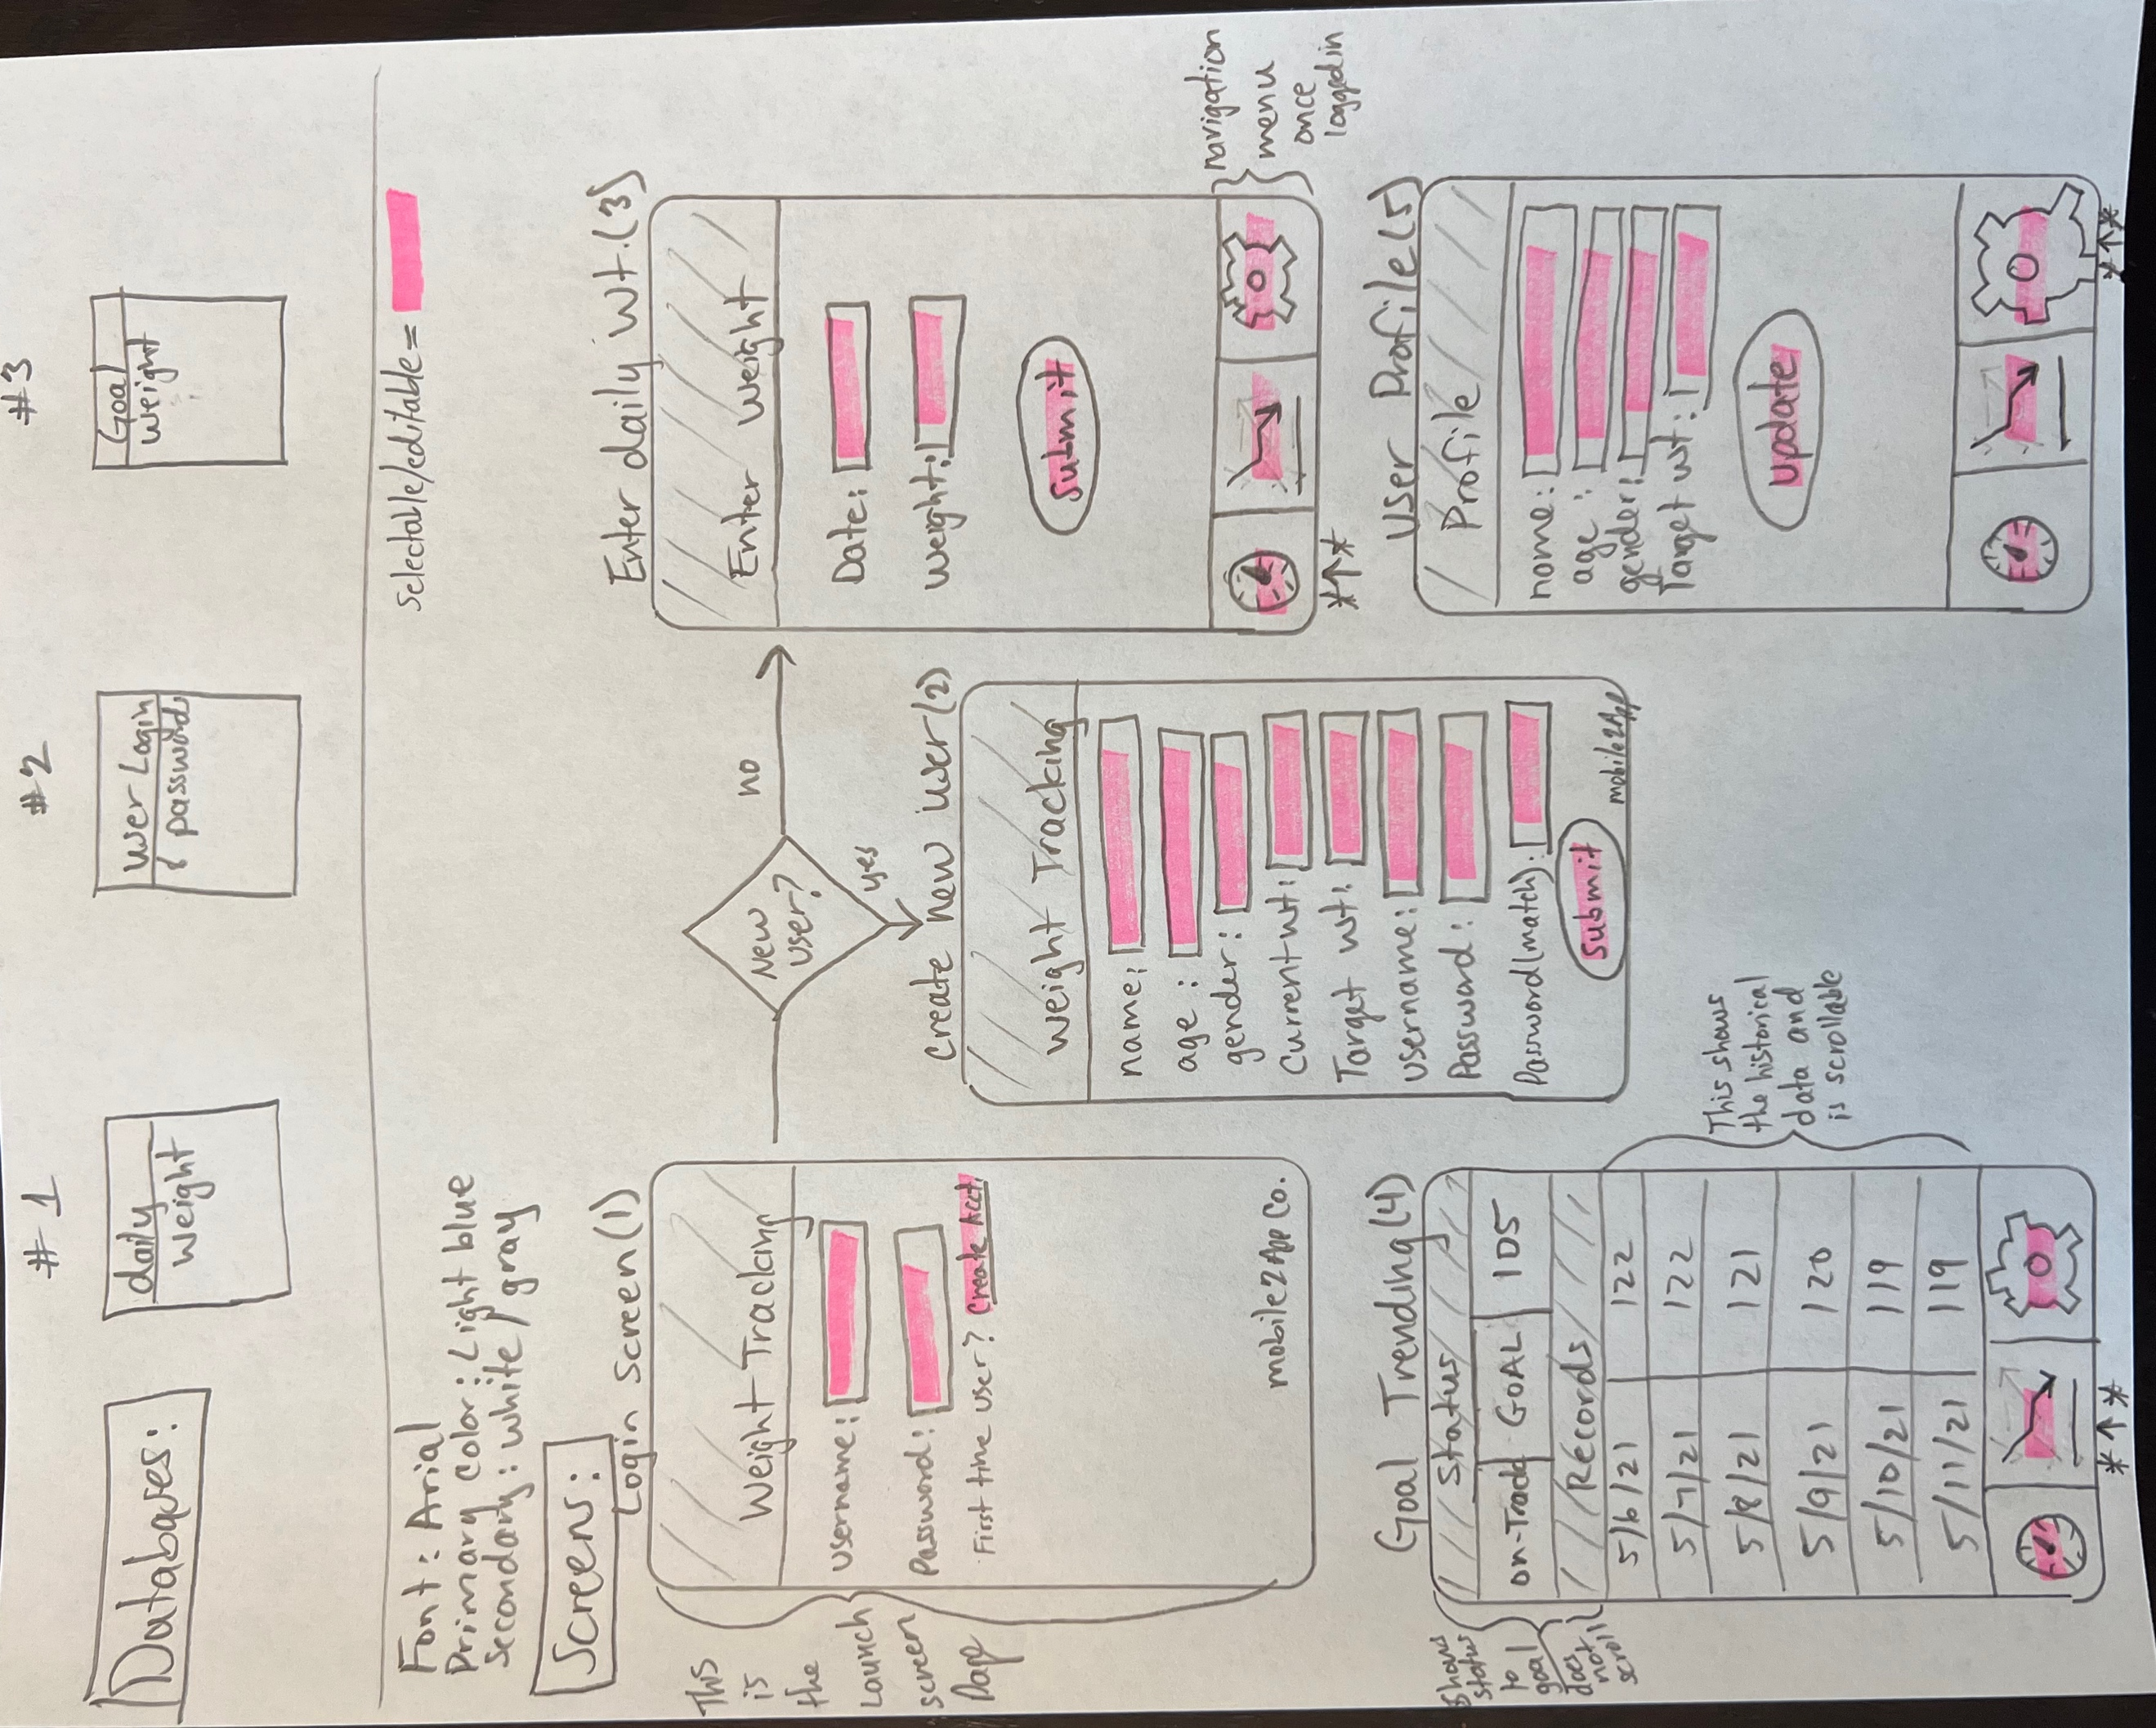

**Functionality**

The functionality of the app is listed below in reference to the requirements of the project.

|  |  |
| --- | --- |
| Requirement | Response |
| A database with at least three tables: one to store the daily weight, one to store user logins and passwords, and one to store the goal weight. Note that goal weight will be constant but setting a one-time weight that is stored in a database will be the simplest way for you to accomplish this task. | See below database section of the drawing showing this inclusion and reference. |
| A screen for logging into the app; note that this should also be used to create a login if the user has never logged in before | This provision has been accounted for in the design for having the login screen be the first screen that is shown at all app launches. There will be additional provisions for the user to create a profile if they do not currently have an existing account. The "login and password" databased will be queried when a user attempts to login to validate the profile exist, or if a new user is creating a profile. |
| A screen, with a grid, that displays all of the daily weights and the days they were entered | This provision will be accounted for on screen (4) "Goal Trending". This will show the historical records, goal, and status. This data will come from the appropriate database and be viewable in the scroll section |
| A mechanism by which the user can add a daily weight | This provision is accounted for in screen (3) "Enter daily Wt." This screen is specifically designed to gather daily input from the user and add the data to the records database. |
| A mechanism by which the user can add a goal weight | This provision is accounted for in the user profile and account creation workflows. This is also modifiable when looking at screen (5) "User Profile". |
| A mechanism by which the application will notify the user when they reach their goal weight | This provision will be accounted for on screen (4) "Goal Trending". This will show the historical records, goal, and status. The status will change from "on track" to "goal reached" with daily weight is less than or equal to the goal/target weight. |

**References**

*Navigation bar – Material Design 3*. (n.d.). Material Design. <https://m3.material.io/>

components/navigation-bar/guidelines